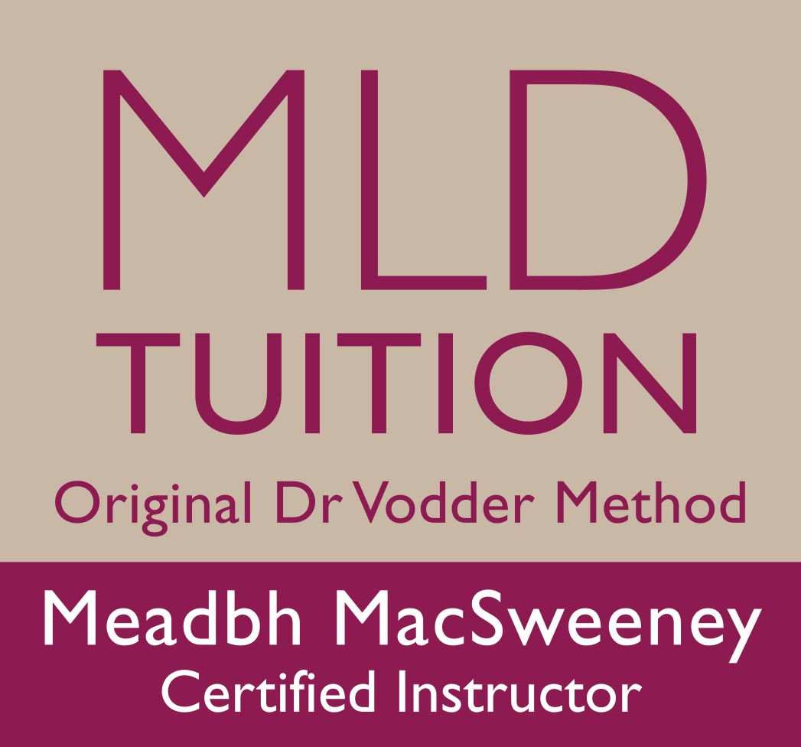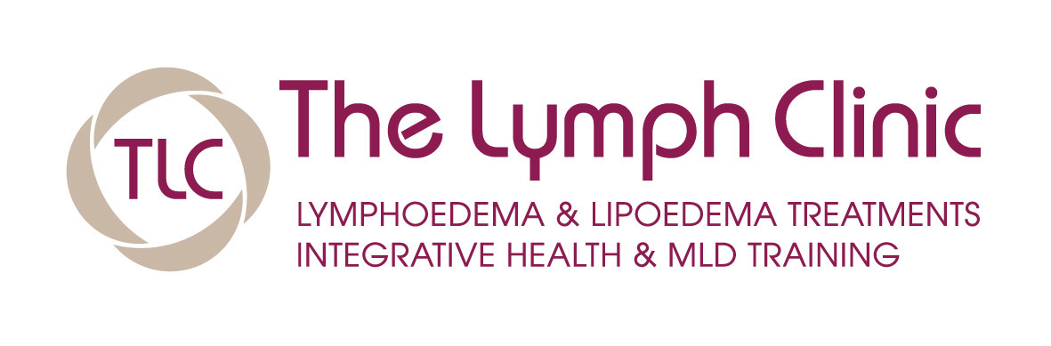

Manual Lymph Drainage, (MLD) Origional Dr Vodder Method Post Graduate Training. COURSE ENTRY REQUIREMENTS
Courses are held in Cork. All students must complete Basic before going on to Therapy 1. Therapy 1 is an exam course and certifies you to work on people with an intact lymph system. Therapies II & III modules cover primary & secondary Lymphoedemas, vascular oedemas and other lymphatic related disorders and their treatment in the context of Decongestive Lymphatic Therapy (DLT).

Post graduate Entry Requirements:
In order to enrol on a Basic level course in the Original Dr. Vodder Method you need to provide evidence of pre-existing levels of relevant training and experience as detailed below. Anything less is considered to be insufficient in preparing the prospective student for the rigours of Dr. Vodder's MLD training and subsequent clinical practice. The Directors of the Dr. Vodder Academy International stipulate the following minimum standards to enrol on the Basic (Foundation) course

Entrants coming from a medical /paramedical background:
Potential students with a medical background such as doctor, nurse, chiropractor, osteopath,physical therapist or physiotherapist have automatic entry to the post graduate course. Countries (such as Canada) with a state registered massage therapist occupation (requiring a minimum of 2,200 hours of training) are included in this category. Evidence of your qualification and/or medical registration number need to be submitted with your completed application.

Entrants coming from a non medical /paramedical background:
Potential post graduate students with massage therapist training need a minimum of 340 hours training and exam success.
The practical (hands-on) element must have been in the class room or supervised for a minimum of 250 hours. If home study and/or case histories formed part of the course these must have been documented and submitted for assessment by the course provider. The exams must have been taken in person and passed.
The theory elements (anatomy, physiology & pathology) must be for a minimum duration of 94 hours and may be in the class room or home study (including on-line). The exams must have been taken in person (and if on-line, at a supervised examination centre) and passed.
Proof of your qualifications and/or medical registration number need to be submitted with your completed application form. Photocopies and/or scans are acceptable.
If you are not sure whether your existing qualifications meet the requirements then please contact us at The Lymph Clinic, meadbh@thelymphclinic.ie

Dates for 2019
Basic Friday March 22nd to Tuesday March 26th
OR Friday October 18th to Tuesday October 22nd
Therapy 1 Friday April 19th to Tuesday April 23rd
OR Friday November 22nd to Tuesday November 26th
_____________________________________
Therapy 2 : Saturday 20th July to Wednesday 24th July
OFF July Thursday 25th & Friday 26th
Therapy 3 : Saturday 27th July to Thursday 1st August
Theory Exam / Compression garment companies/ volume & limb measurements etc Saturday 27th, Practical exam Thursday 1st August ( Finish lunchtime)

Contact meadbh@thelymphclinic.ie for more info or go directly to www.thelymphclinic.ie for downloadable or E booking forms

.

